**2017**

MAAZ,ISRAR,SHAHRUKH

M.C.A Glocal University

1/16/2017

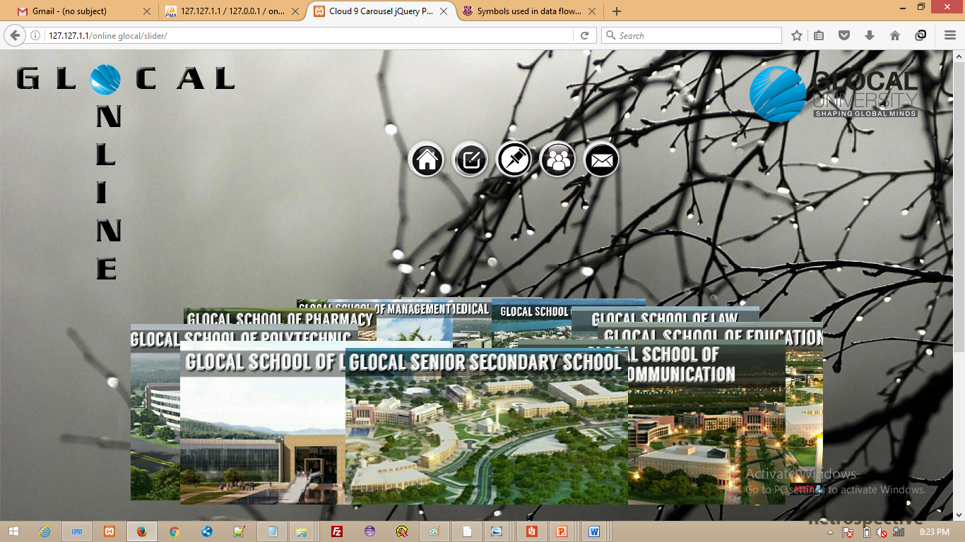

GLOCAL ONLINE (M.I.S.T)

**Glocal Online**

A PROJECT REPORT

***Submitted by***

GU13R0080 MOHD MAAZ

GU13R0079 MOHD SHAHRUKH

GU13R0069 MOHD ISRAR

***In partial fulfillment for the award of the degree***

***of***

**MASTER OF COMPUTER APPLICATION**



DEPARTMENT OF COMPUTER SCIENCE AND ENGINEERING

GLOCAL UNIVERSITY

**SAHARANPUR - 247121**

01-2017

**GLOCAL SCHOOL OF TECHNOLOGY**

**GLOCAL UNIVERSITY, SAHARANPUR, 247121**



**BONAFIDE CERTIFICATE**

This is to certify that the project report entitled “**GLOCAL ONLINE”** submitted by “MOHD MAAZ (GU13R0080) ,MOHD SHAHRUKH (GU13R0079),MOHD ISRAR(GU13R0069)” in partial fulfillment of the requirements for the award of the **Degree Master of Computer Application** in “**COMPUTER SCIENCE** Engineering” is a bonafide record of the work carried out under my guidance and supervision at Department of Computer Science and Engineering, Glocal University, Saharanpur.

NAME OF SUPERVISOR NAME OF CO- SUPERVISOR

<<Designation>> << Designation>>

<<Department>> <<Department>>

<<Signature of the Chairperson of the Department with date>>

NAME OF CHAIRPERSON-……..

This project report was evaluated by us on ……… (Date...)

INTERNAL EXAMINER EXTERNAL EXAMINER

**ACKNOWLEDGEMENT**

The satisfaction that accompanies that the successful completion of any task would be incomplete without the mention of people whose ceaseless cooperation made it possible, whose constant guidance and encouragement crown all efforts with success

We have taken efforts in this project. However, it would not have been possible without the kind support and help of many individuals and organizations. We would like to extend my sincere thanks to all of them.

We are highly indebted to The Glocal University for their guidance and constant supervision as well as for providing necessary information regarding the project & also for their support in completing the project.

We are grateful to Mr. Sachin Michu for the guidance, inspiration and constructive suggestions that help us in the preparation of this project without whom we will never be able to complete this project.

We would like to express my gratitude towards our parents for their kind co-operation and encouragement which help us in completion of this project. They are the ones who always stood by us no matter what.

Our thanks and appreciations also go to our colleague in developing the project and people who have willingly helped us out with their abilities.

**Mohd Maaz**

**Mohd Shahrukh**

**Mohd Israr**

**ABSTRACT**

This is an Intranet Portal for Glocal University project in which we are developing a dynamic website. developed in PHP. We also used HTML5, CSS3 and Javascript to complete this Project. glocal Online is a platform for sharing of notes.It perfectly classifies all kind of notes into departments. There are two kind of accounts in this portal one is Faculty and another one is of Students. When you enter in the portal you have choice to see all the departments without login ,but those notes will not be classified in the official & unofficial categories.

Once the user login the system he has various choice he can view notices or if the user is a faculty then he can upload a notice also

If the user is facing a difficulty in order to use the portal then he can message his query to admin. His query will be published at the moment and immediately his query link to the admin reply.

So we see this portal perfectly solving the problem of sharing of notes in a uniform manner. User also don’t need to have internet access to use it, They just need to be there in the network of Glocal ,

This project need to used by all the faculties of Glocal it will not only be useful but encourage able to development team (M.I.S.T) and other student also as they will observe whatever is being developed is not only for just pass the course and get a degree , but can be used in the particle environment and prone to be benefited for the student and faculty

**TABLE OF CONTENTS**

* ACKNOWLEDEGEMENT
* ABSTRACT
* TABLE OF CONTENT
* INTRODUCTION
* WHY DEVELOP GLOCAL ONLINE ?
* TECHNOLOGIES USED
* FEASIBILITY STUDY
* ECONOMIC FEASIBILITY
* TECHNICAL FEASIBILITY
* BEHAVIOURAL FEASIBILITY
* SOFTWARE DEVELOPMENT MODEL
* DATABASE & DATA TABLES
* WEB PAGES
* DATA FLOW DIAGRAM
* ENTITY RELATIONSHIP DIAGRAM
* FUTURE SCOPE
* CONCLUSION
* BIBILIOGRAPHY

**INTRODUCTION**

An intranet portal is the gateway that unifies access to enterprise information and applications on an intranet work. It is a tool that helps an organization manage its data, applications, and information more easily, and through personalized views

Online Discussion & File Sharing Forum is a Web Application developed for online file, notes sharing & discussion

For each department there is a separate section where a user can post his notes, or anything to share so it could be helpful for others.This portal even have a notice board. Where a faculty can upload a notice. This will be visible to everyone.

**Why developed GLOCAL ONLINE?**

The purpose of developing this Application is to change the traditional way of notes sharing in Glocal, though already there are various online platform those are working efficiently, but many of them don’t have a user friendly interface and can’t be used with in a LAN, this Application can be easily installed in glocal’s server and would be accessible through LAN

There was a great need of development of the portal where sudents can upload and download all kind of notes ,and so far his is he first portal o serve this requirement

It would definitely change the way of notes sharing and also encourage other guys to make something usefull for university in terms of saving time money and many other resource

**TECHNOLOGIES USED**

* **PHP**
* **HTML**
* **CSS**
* **JAVASCRIPT**
* **BOOTSTRAP**
* **MYSQLi**

**SOFTWARE DEVELOPMENT MODEL**

We have successfully completed our project but this project might have failed if we haven’t followed any of the software development models available to us. There are a number of software models which are available which one needs to follow in order to achieve its goal with more reliability. There are models like waterfall model, spiral model, agile development model, RAD (Rapid Application Development) model and many others. So according to the need of the user he/she chose their own software development model out of these.

We have chosen AGILE SOFTWARE DEVELOPMENT MODEL to develop our website. This is one of the best software development models for the kind of website we have developed. In agile software development there is iteration and after each iteration we increment the functionality of the software.

Here we divided the work as per the planning and carried it out and within a very short period of time we have developed this website.

We again and again kept on checking the basic requirements of the project and keep working on them.

**FEASIBILITY STUDY**

***ECONOMIC FEASIBILITY***

The Web Application developed i.e. GLOCAL ONLINE is economic with respect to users and the university. The Application is also time effective, whenever someone wanted to upload or download anything that thing could be done very quickly and it is only because of the well structured backend & GUI of the Website which is very user friendly and very simple. We do not require any special hardware or software machinery to build this website. All we need was the knowledge of the technologies we used in this and the software we used which were Notepad++ and Xampp, both of which are freely available and does not require any other special knowledge except of technologies we require while developing it.

***TECHNICAL FEASIBILITY***

The technical requirement for the Application is economic and it does not use any other additional Hardware and software. It is running on browser so portability and platform independency is also there. Our website can be easily accessed via any browser on your laptop or personal computer or even any device in which you can access internet. So it is technically very feasible to use.

***BEHAVIOURAL FEASIBILITY***

The functioning of Application is quite easy to use and learn due to its simple but attractive interface. User requires no special training for using this Web Application. It is like any other website which anyone can use. Users don’t require to involve in a complex activity for uploading or downloading or upload anything. They can simply post their notes.

**D.F.D of GLOCAL ONLINE**

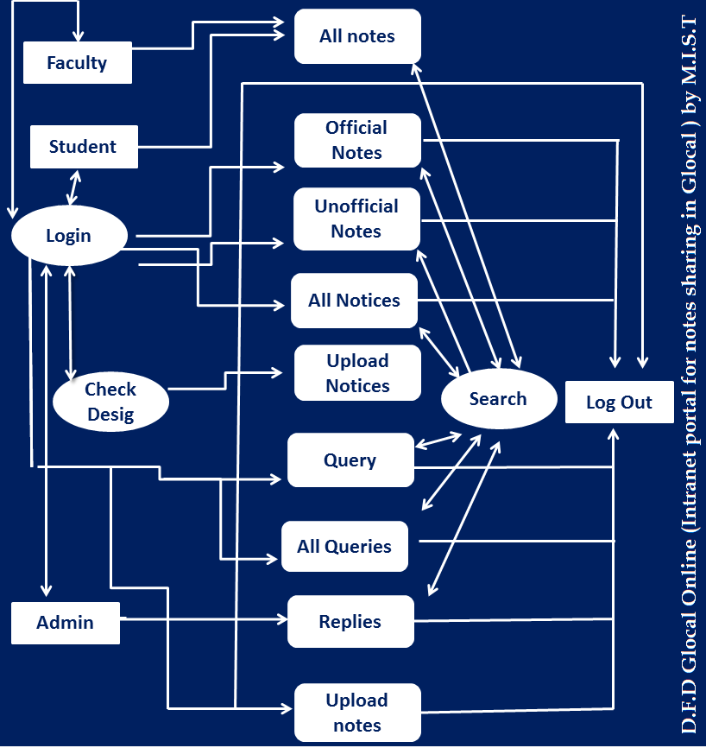

**E.R.D of GLOCAL ONLINE**

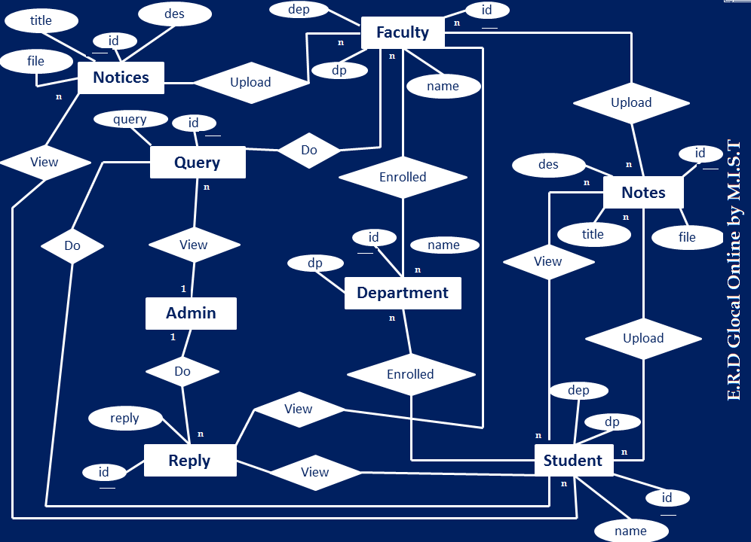

**DATABASE & DATA TABLES**

Database is a kind of store and manager which store. Arrange, manage all the necessary data about the users and the notes they post on the website. Data is stored in different tables according to the type of data which is entered by the user. We have a number of tables in our database. Now if we talk about the database we used while developing this Web Application is MYSQL with the help of XAMPP which creates a local server on our desktop. Data is entered by the user with the help of HTML which with the help of PHP is entered into the database we have created. Now once the data has been entered into the database from then we fetch all the data from there only.

Now we see the data tables we have used in this web application.

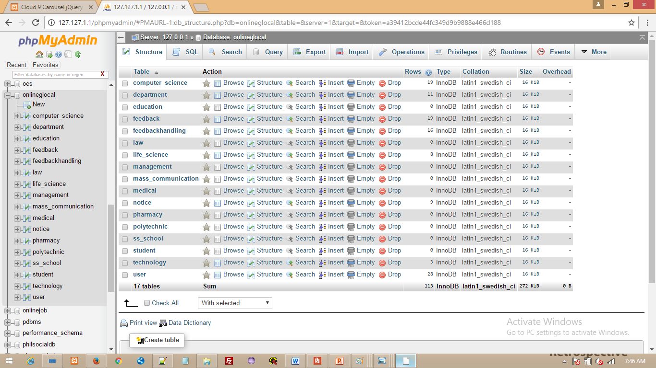

Now we can see that there are 17 tables. Here all he departments have here own table for the sake of less time in searching and parsing. Now we move from table to table and check how data is fetched from this database.

The table departments have the entire list from where the list of departments is

coming on the website. If we have add to any extra departments we can add easily.

**DEPARTMENT TABLE**

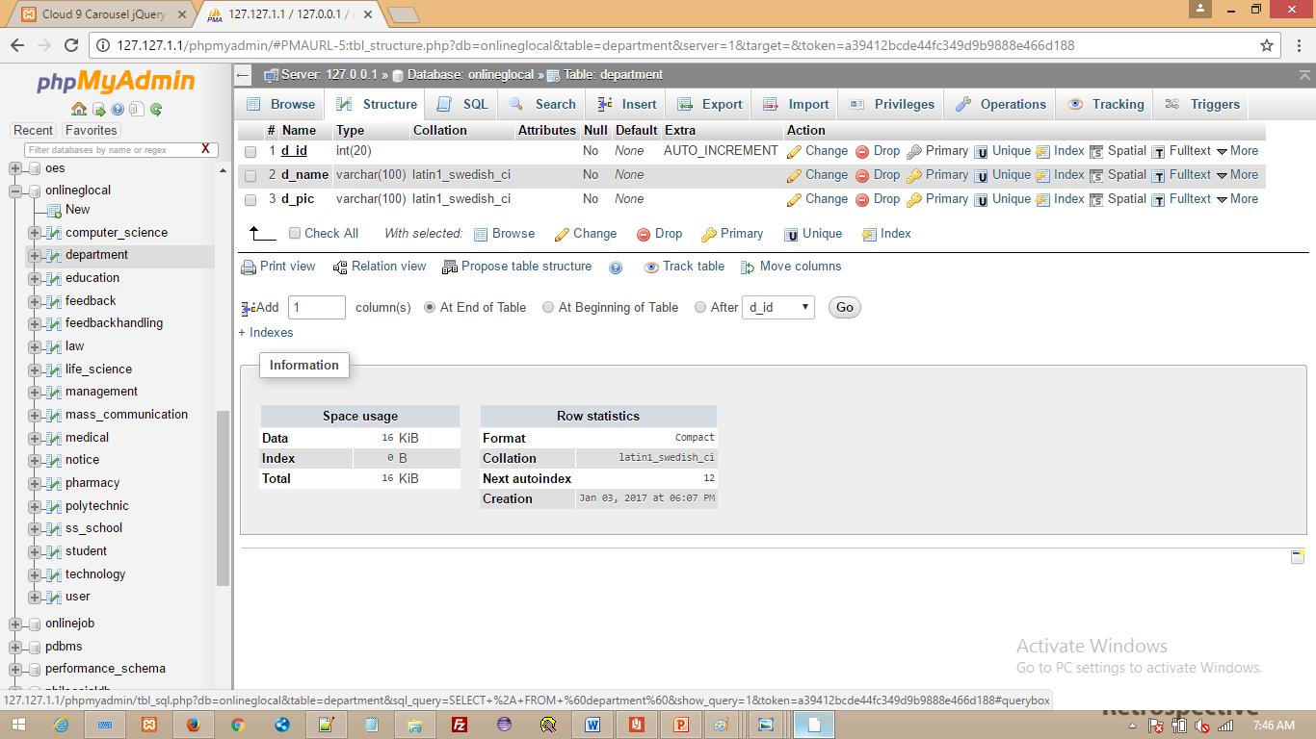

.

**COMPUTER SCIENCE TABLE**

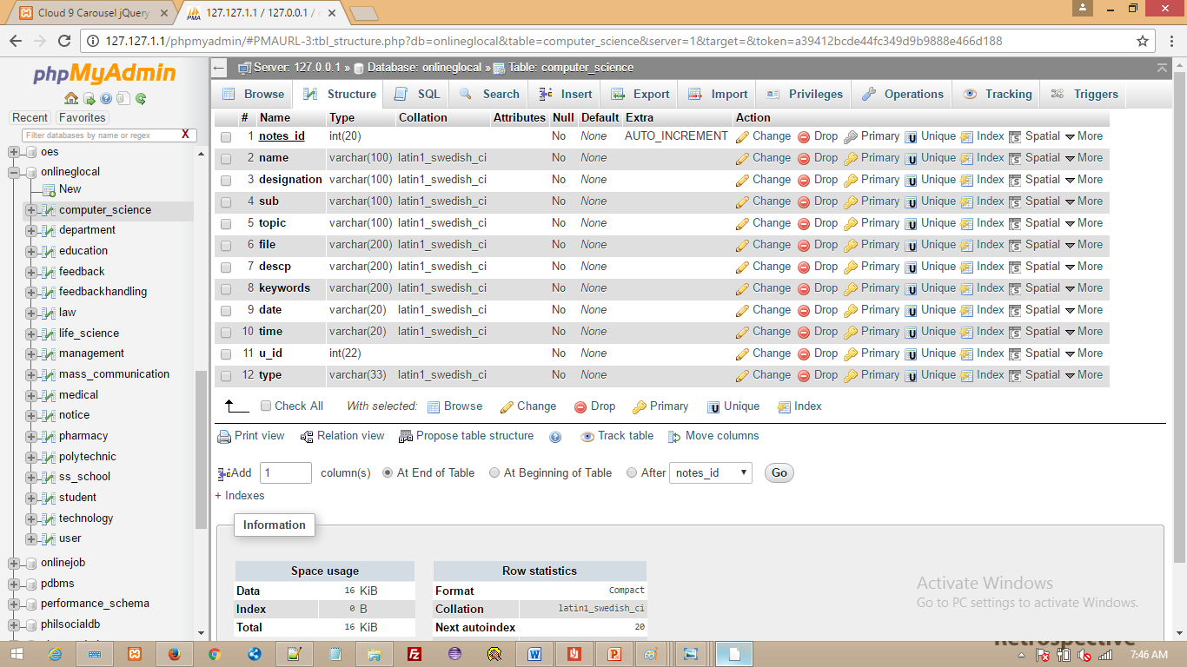

**TABLE FOR HANDLE ALL FEEDBACK**

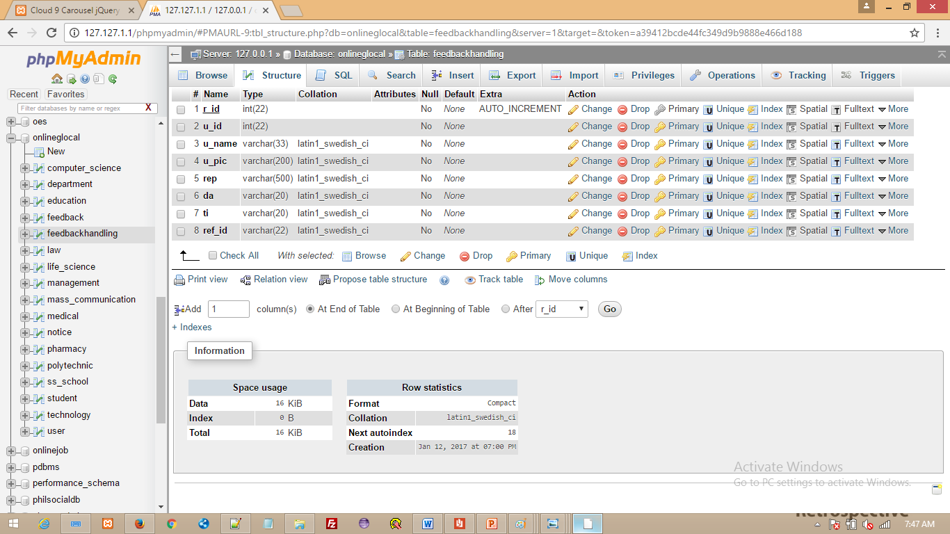

**TABLE FOR STORING USER QUERIES**

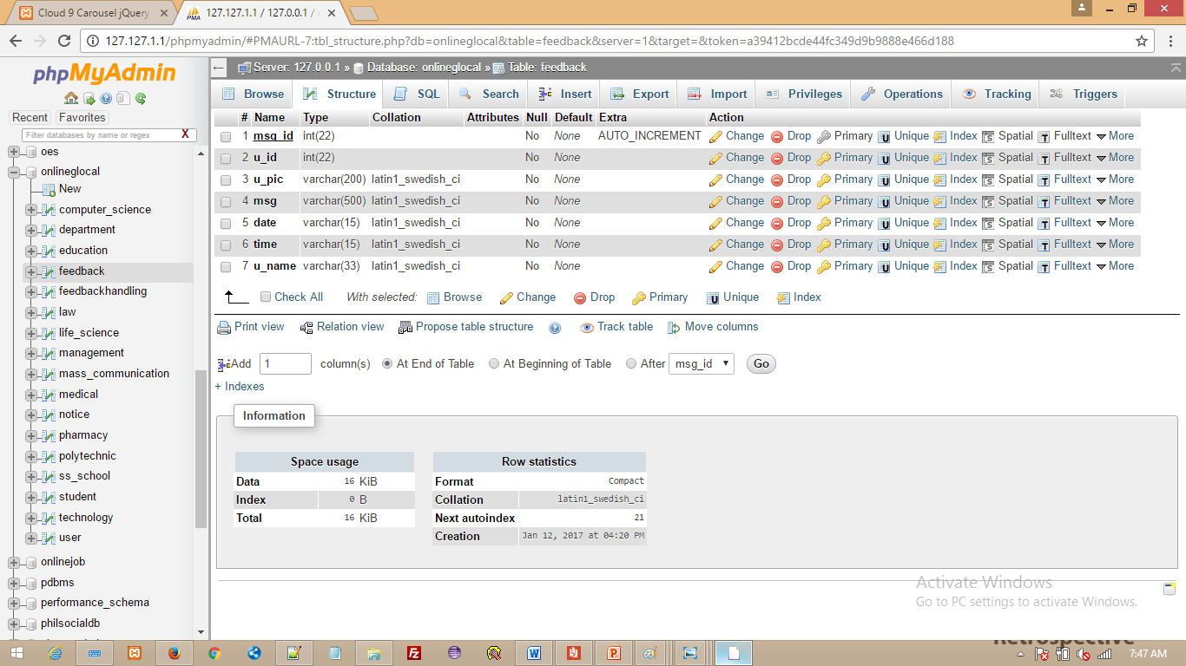

**USER TABLE**

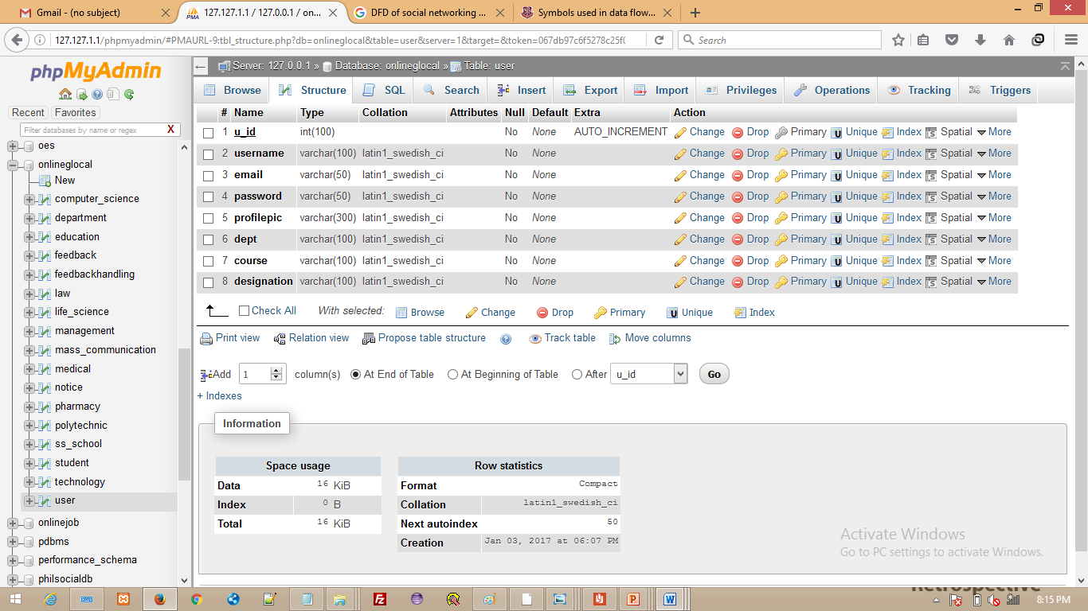

**NOTICE TABLE**

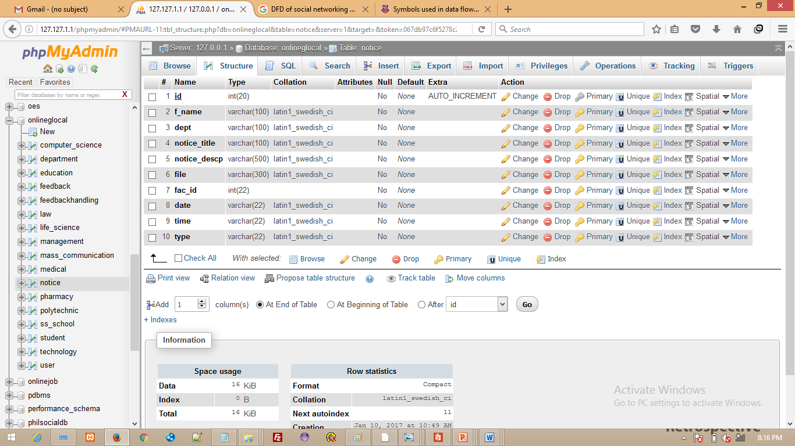

**Home page**



**Login page**

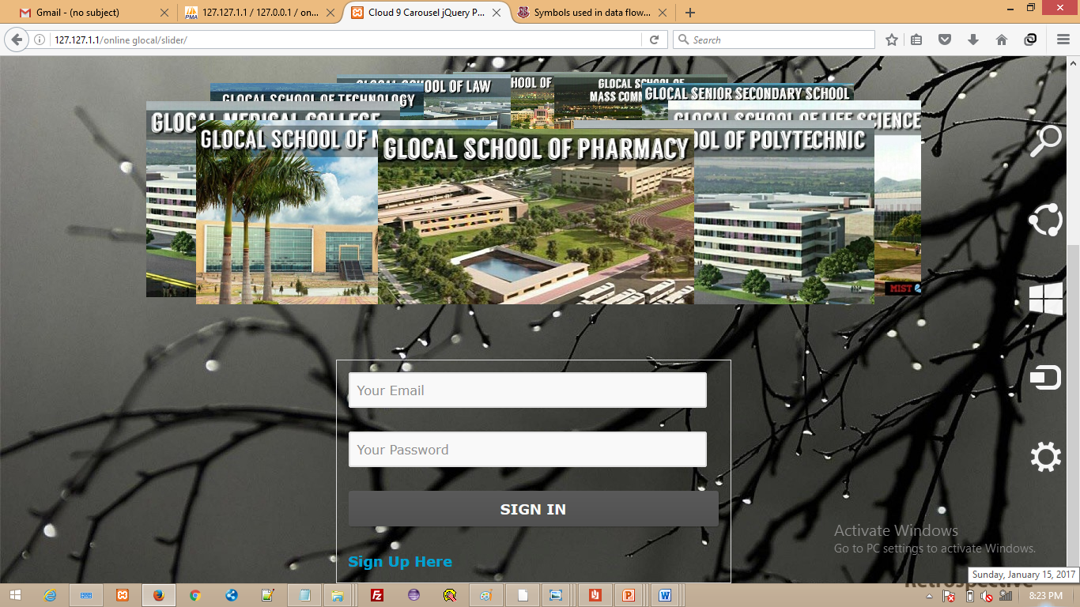

**Sign Up page**

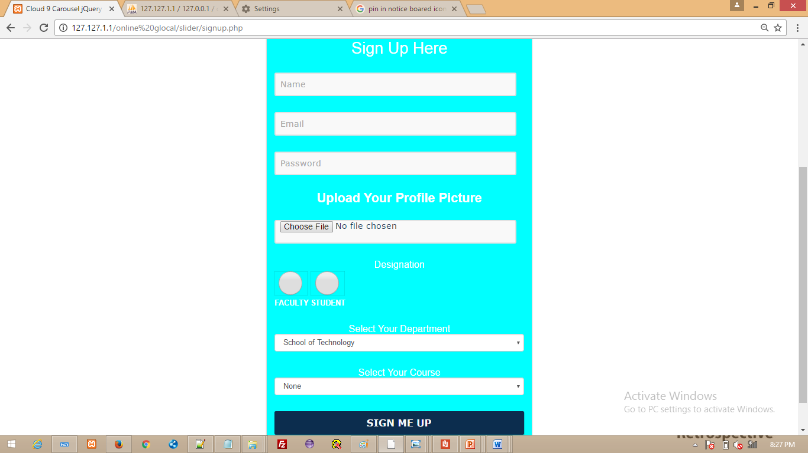

**Profile page**

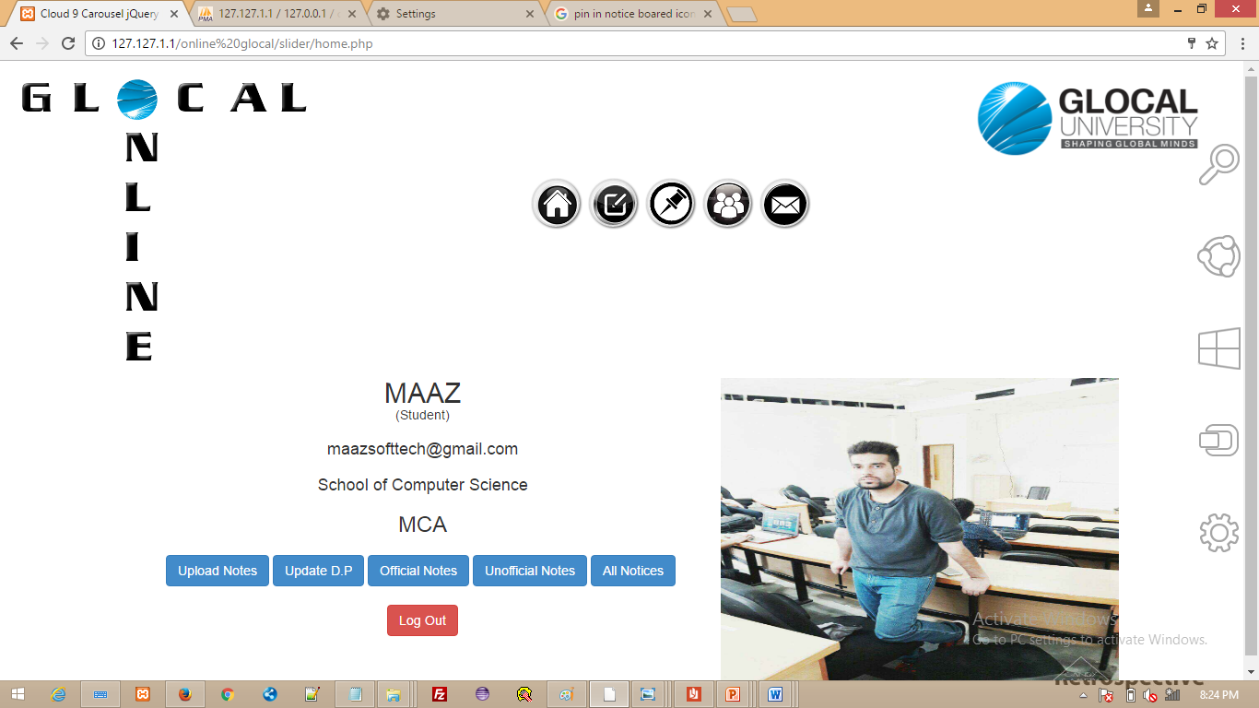

**Upload notice**

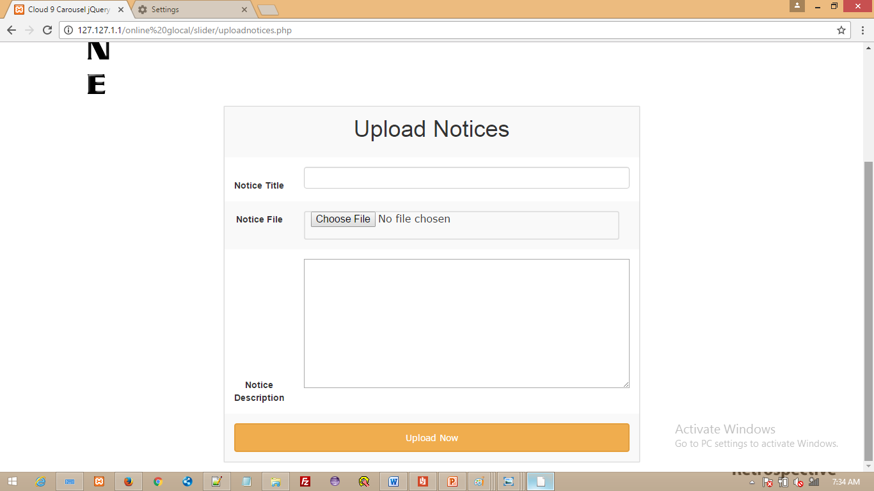

**Notice Board**

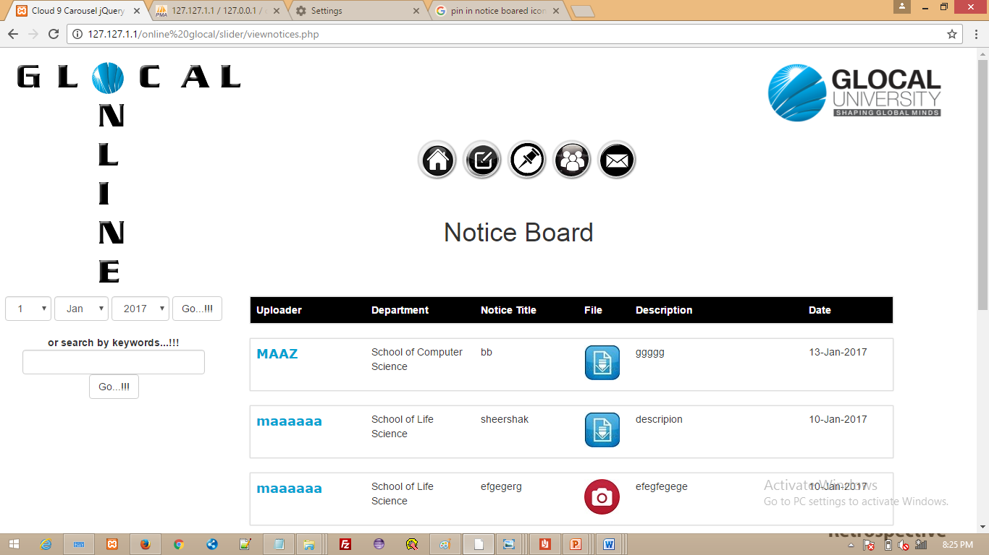

**Upload Notes**

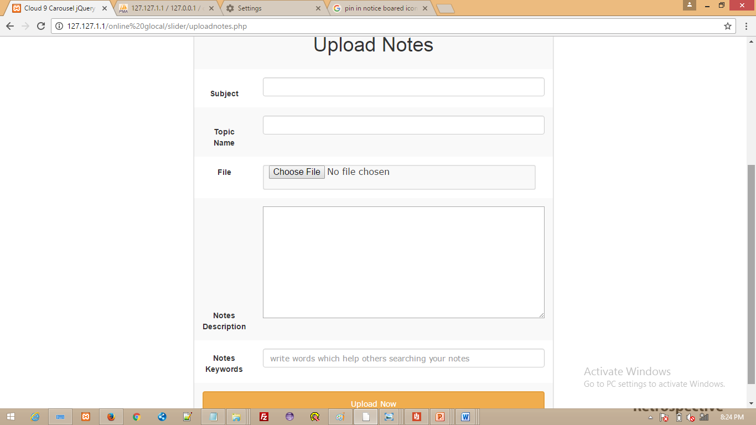

**View Notes**

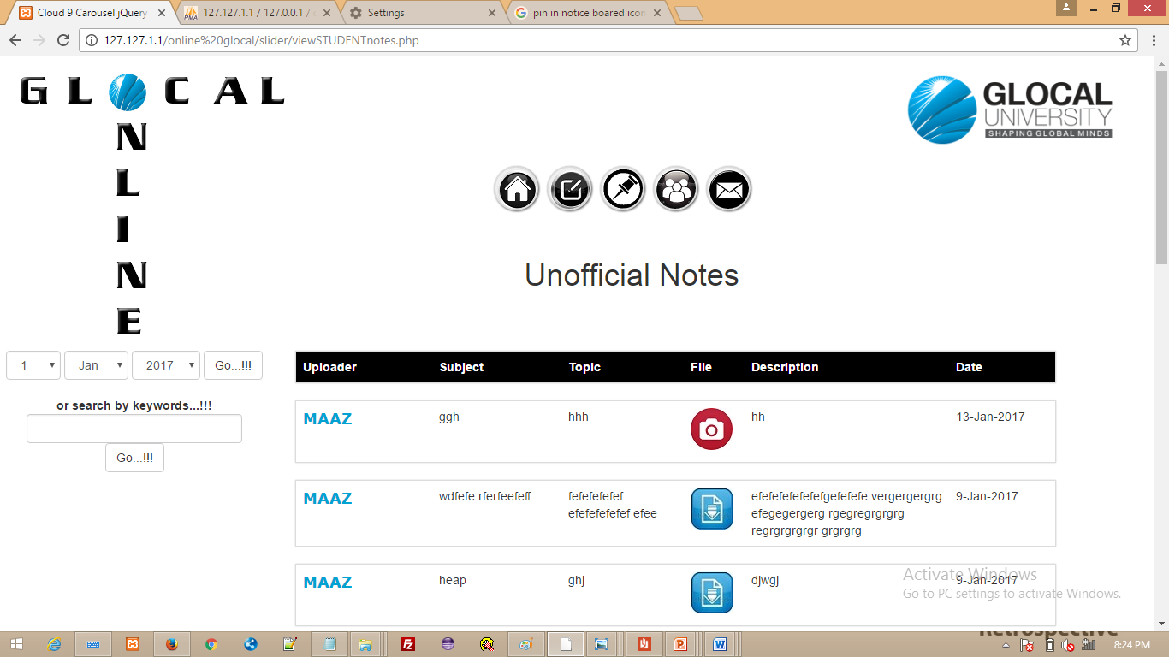

**User Uploads**

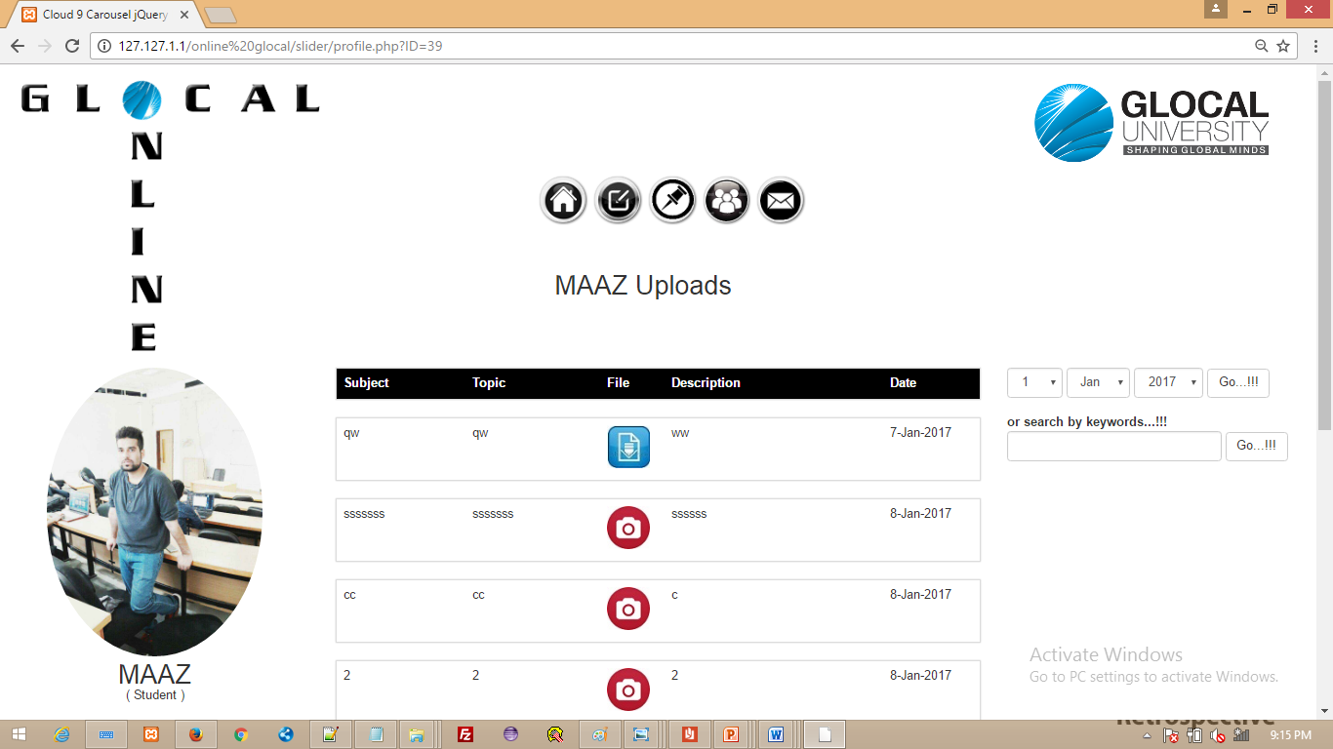

Feedback/query

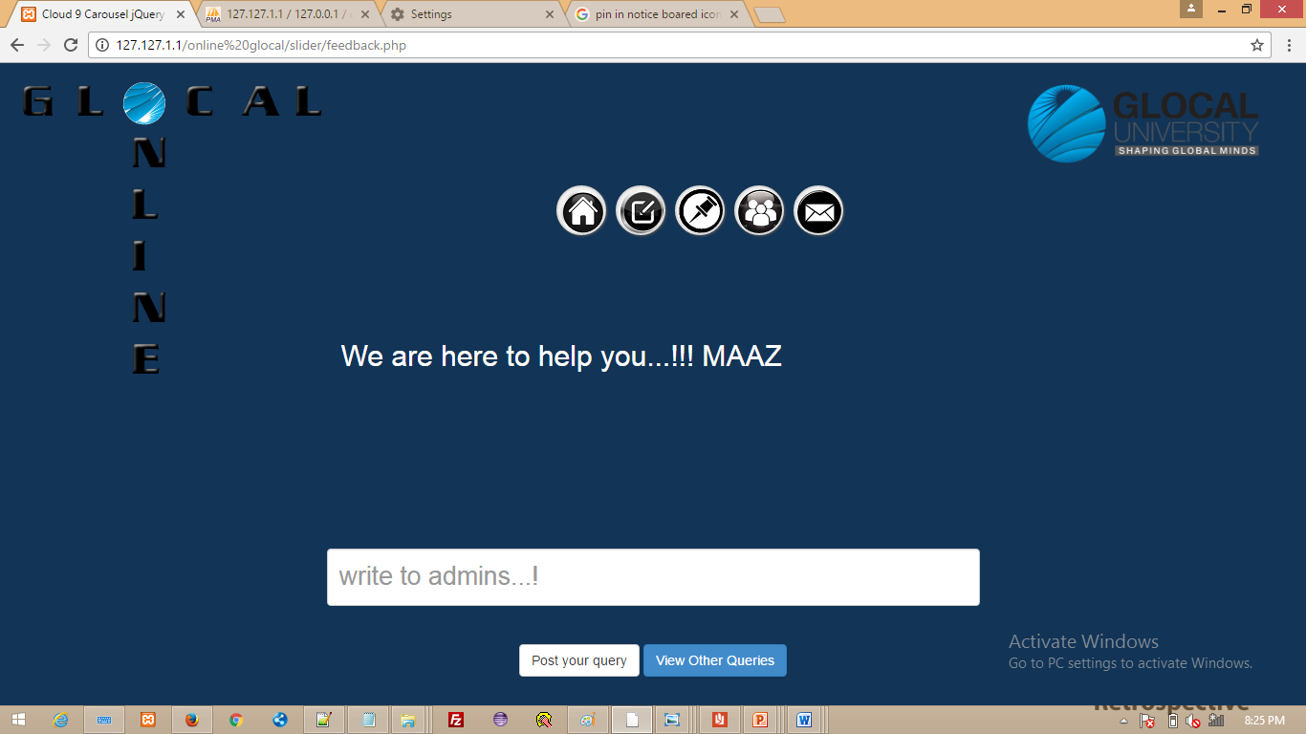

**All Queries**

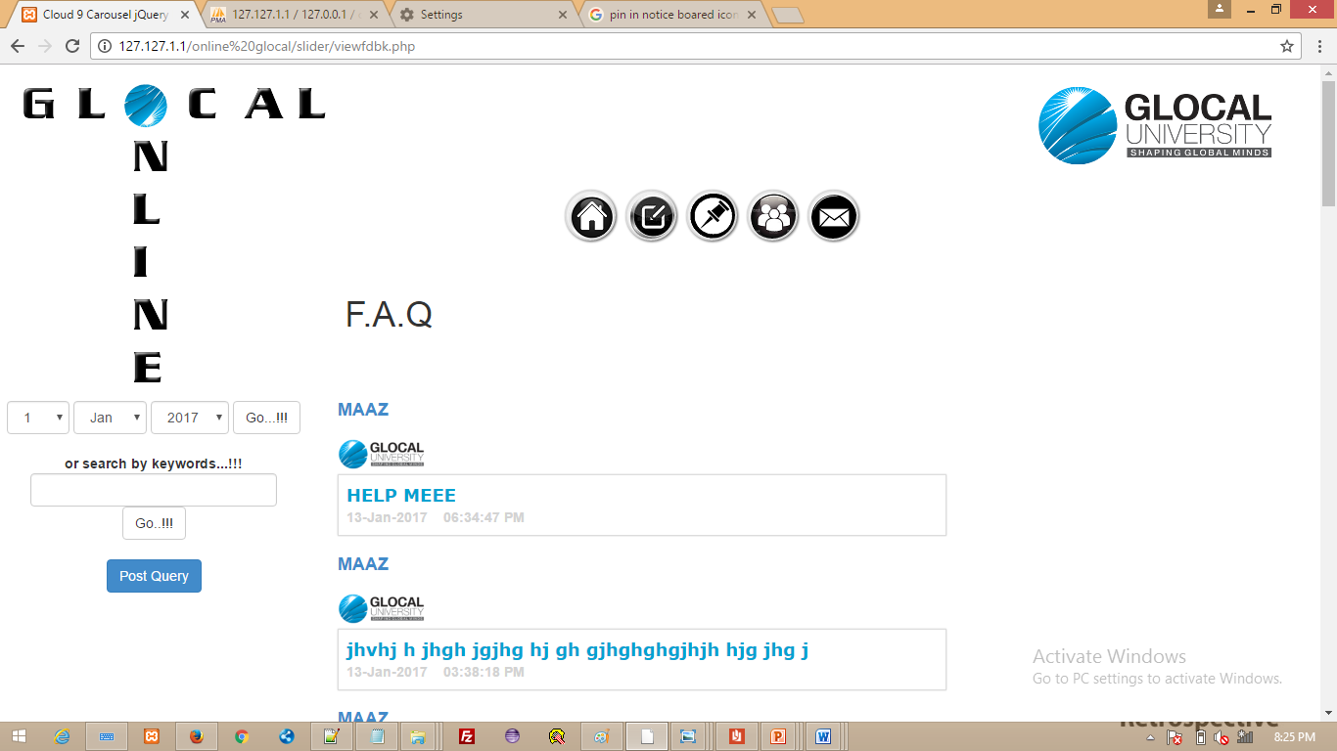

**All replies**

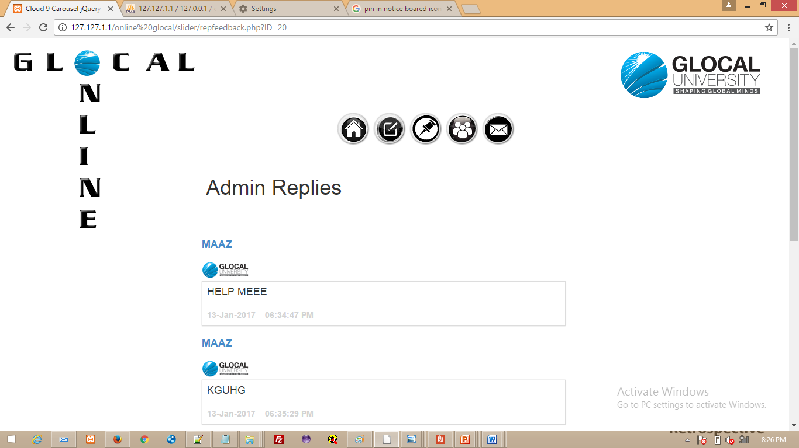

**Update DP**

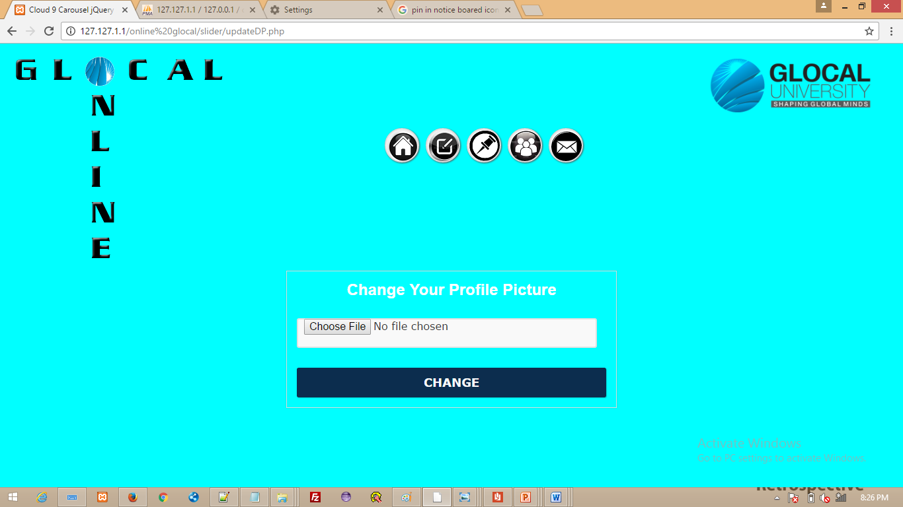

**FUTURE SCOPE**

As we know that this is the first time when a portal like this is created in glocal where people can actually download and upload notes . This portal gives a great platform to the users to actually use it in order to save their money as well as time. Time and Money are the two most important thing today. Who don’t want to save their money and time, it is crucial for everyone today.

There are a number of things which could be added in portal in order to provide much better facility and functionality to the users. Right now the searching system search the notes by just the key word added in database. We are going deploy file content search system in the portal in future

We can further add discussion facility in the website where users can ask questions and discuss amongst each other, which will be very useful for everyone.

Last but not the least we can develop a mobile application in order to reach more and more number of people. We can develop android, iOS as well as windows mobile app. We don’t want to limit its usage to a particular number of people but as many as possible.

So there is a very good future scope for this portal as it good for both students as well as other people.

**CONCLUSION**

The Online notes Sharing portal GLOCAL ONLINE Application is developed using PHP, JavaScript; HTML (bootstrap) with Backend MySql fully meets the objectives of the Application which it has been developed. It has reached a steady state where all bugs have been eliminated. It is operated at a high level of efficiency and the all the user associated with the Application understands its advantage. The Application solves the problem. It was intended to solve as requirement specification.

**Bibliography**

1.w3school.com

2.stackoverflow.com

3. System Analysis and Design – Alias M. Awad

4. Software Engineering – Roger Pressman